P – p – P – p – P – p – P – p

Lernwörter:

🖈✍

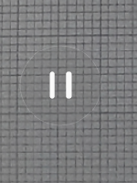

_______________

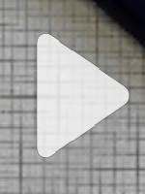

_______________

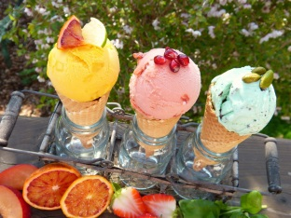

_______________

ice-cream-2202605_1920 by silviarita   
unter <https://pixabay.com/de/eiscreme-speiseeis-eissorten-2202605/>



_______________

